TASK 4

**USING SELECT, WHERE, GROUP BY, ORDER BY**

**A. SELECT & WHERE (with output)**

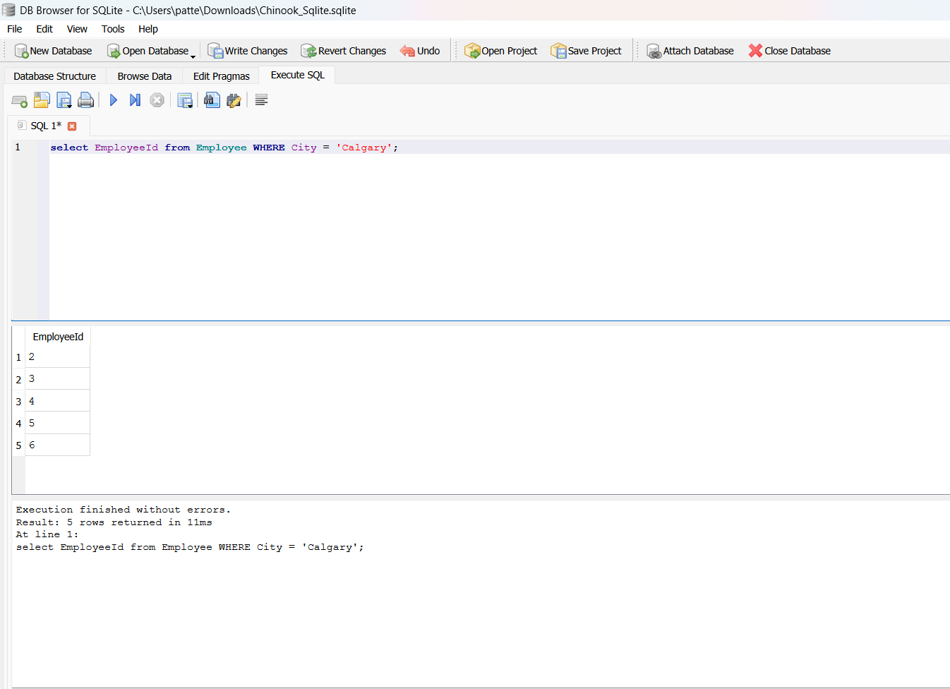

**B. GROUP BY & ORDER BY (with output)**

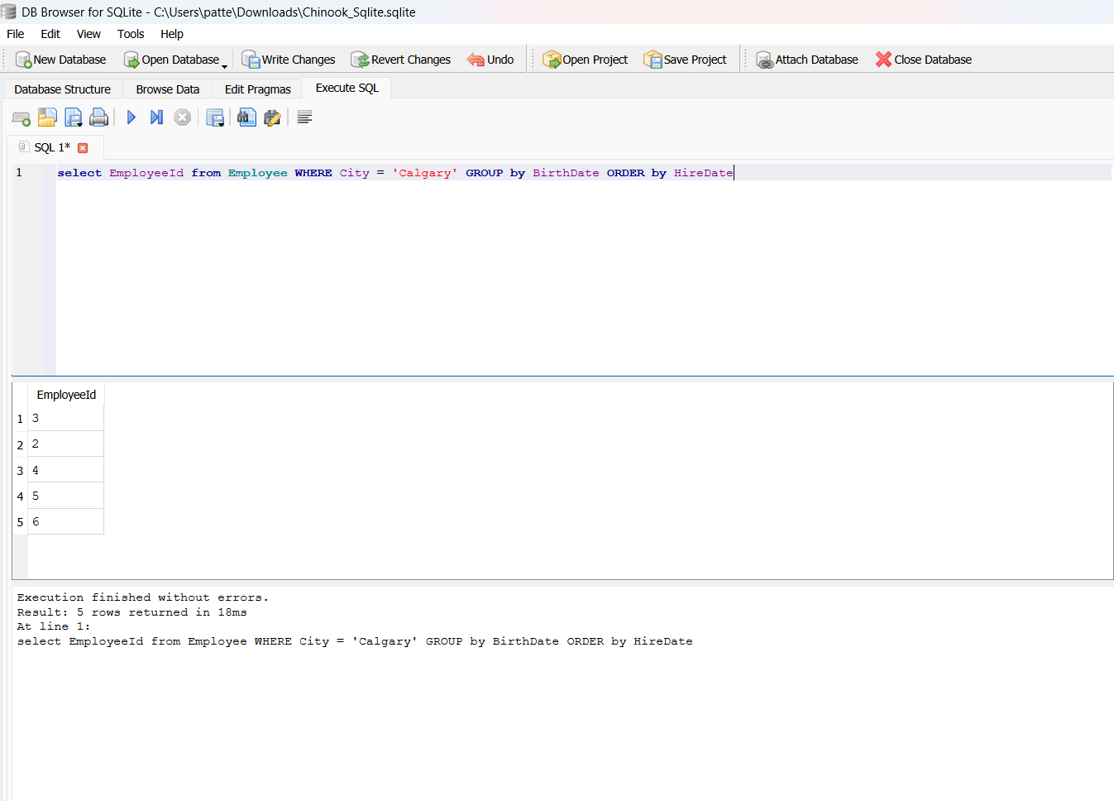

**USING JOINS**

1. **INNER JOIN**

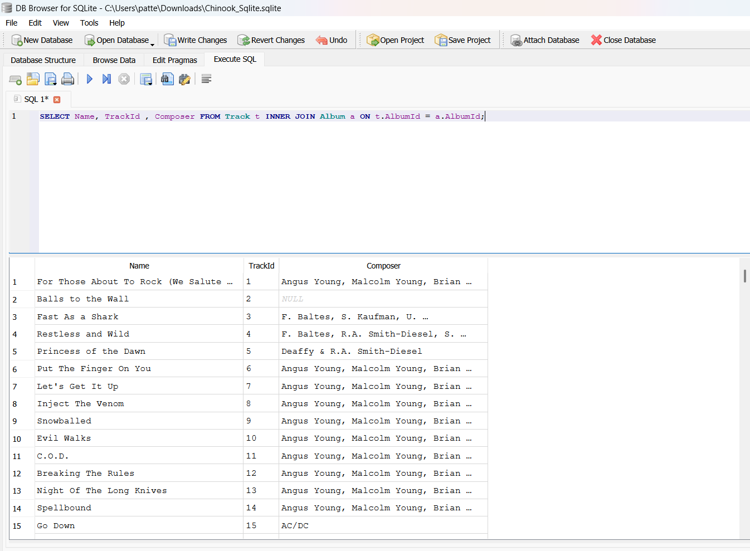

1. **LEFT JOIN**

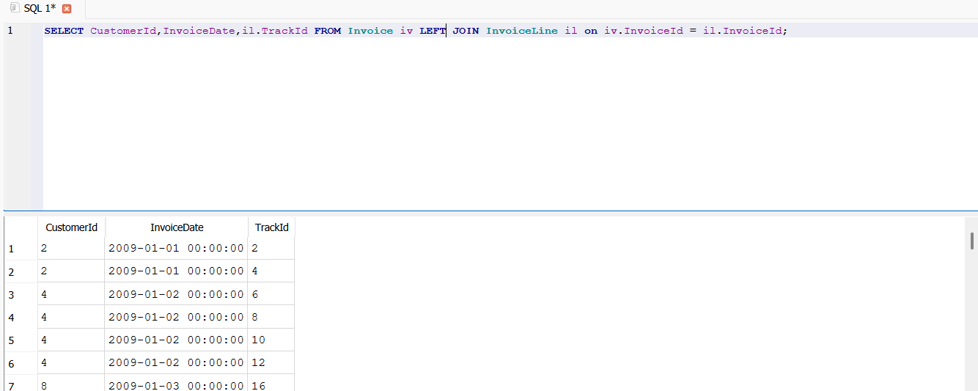

1. **RIGHT JOIN**

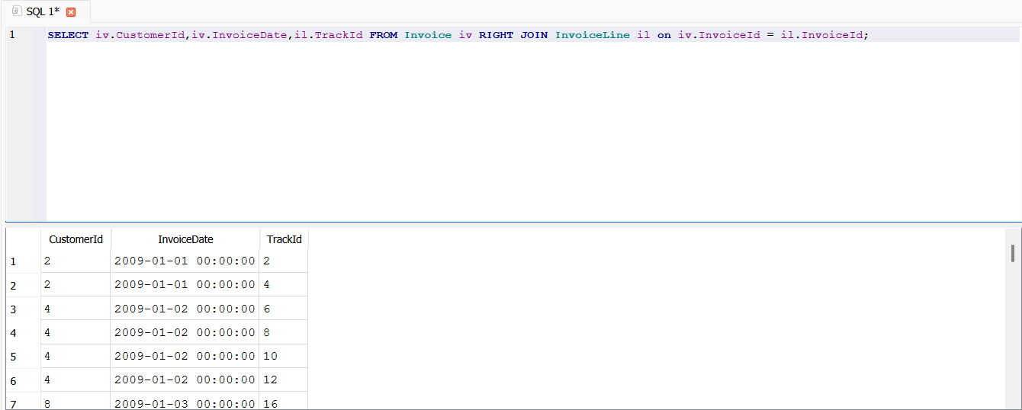

**USING SUBQUERIES**

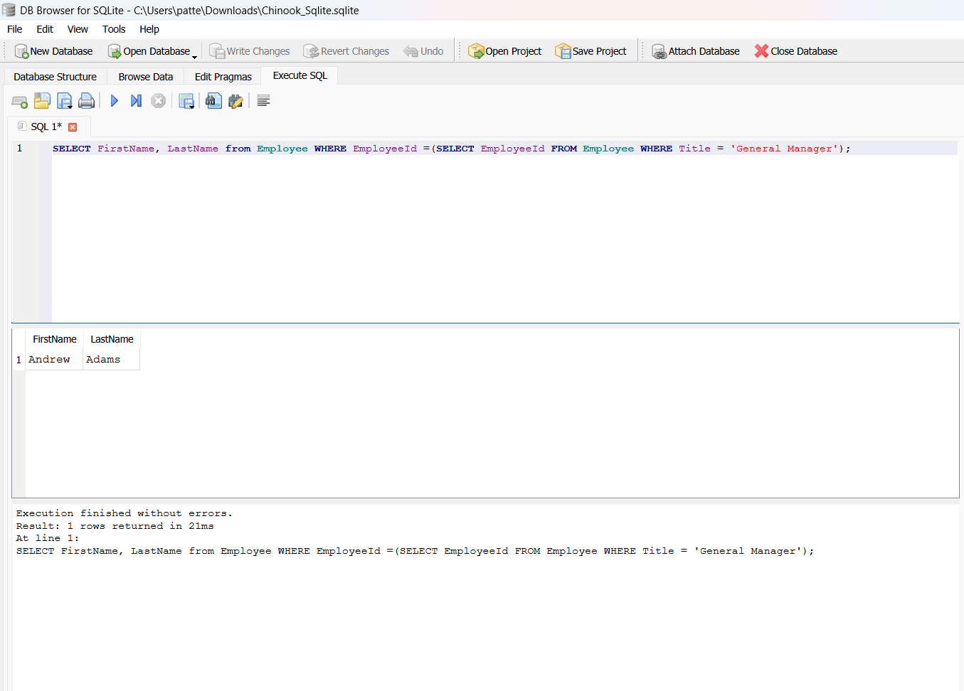

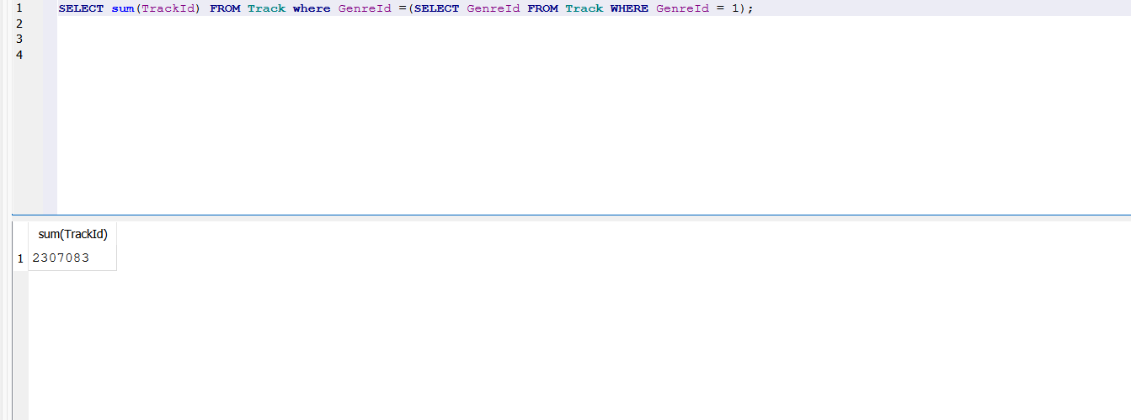

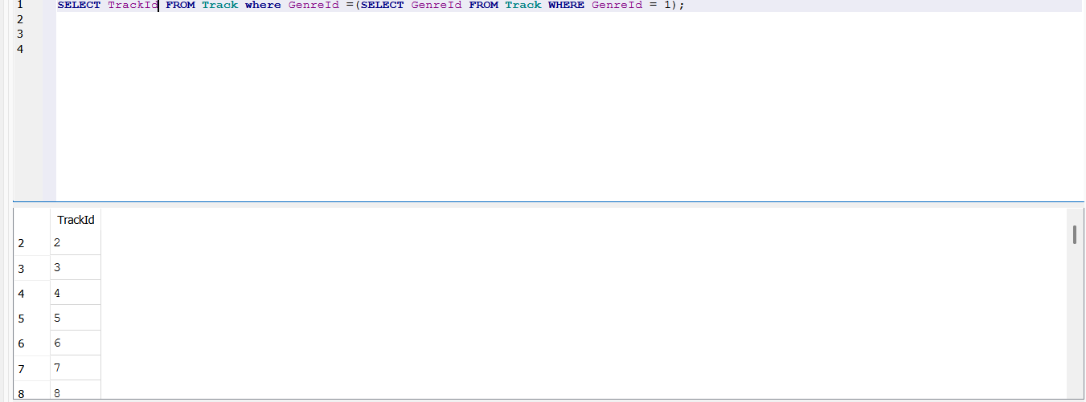

**VIEWS**

**Creating**

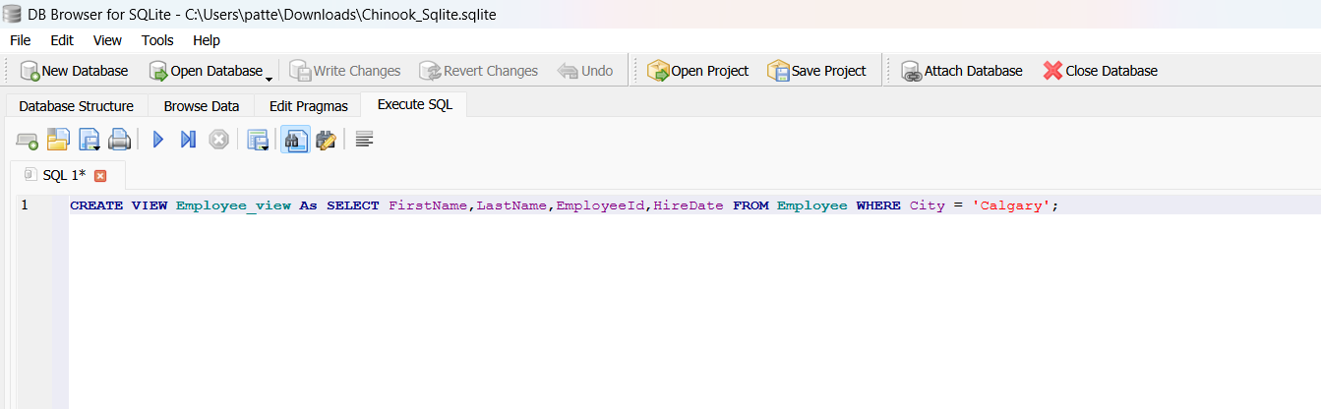

**Retrieving**

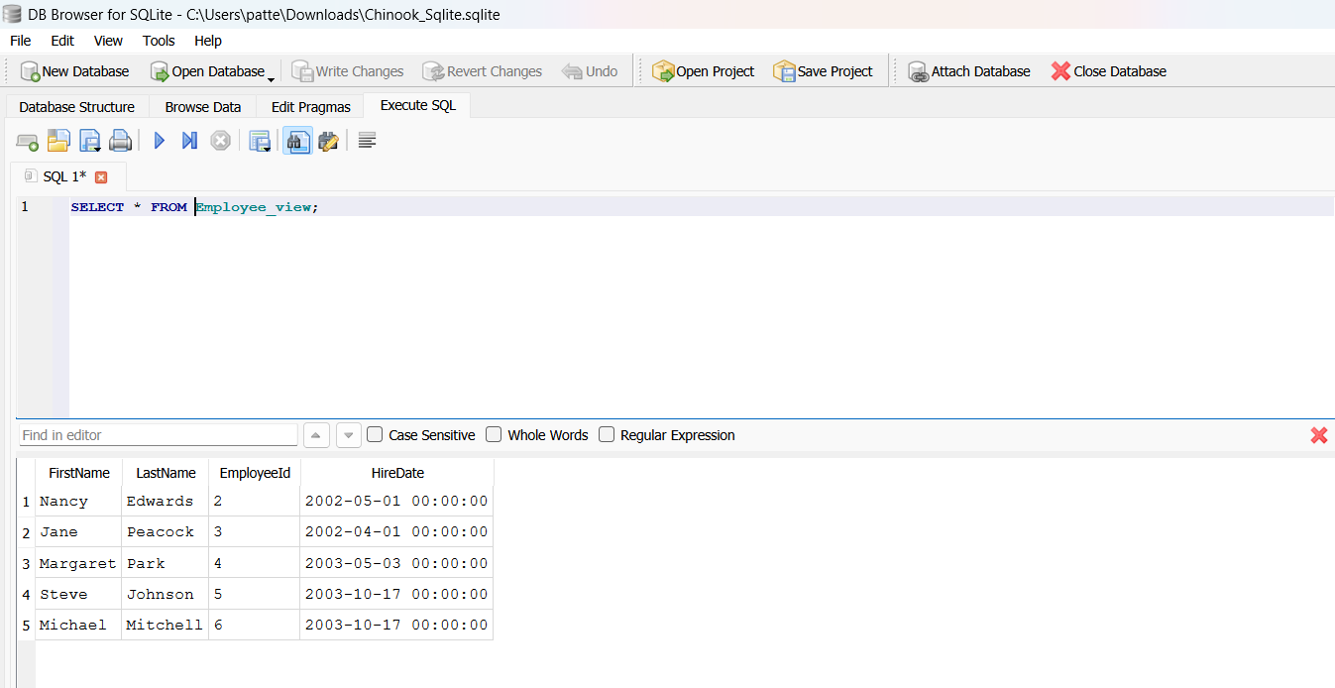

**USING AGGREGATE FUNCTIONS**

**SUM & AVG**

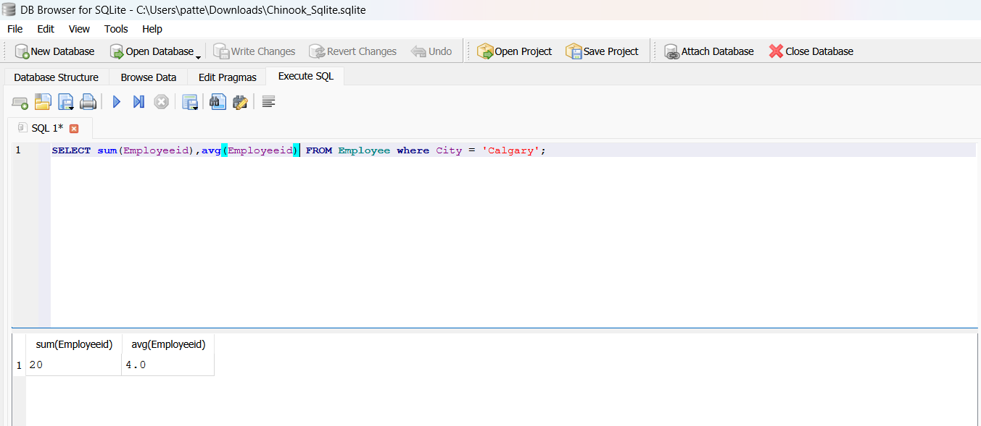

**INDEXES**

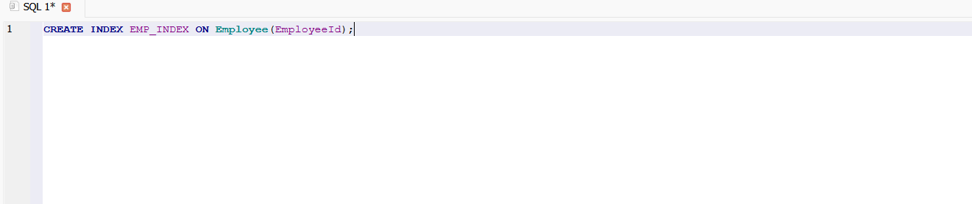

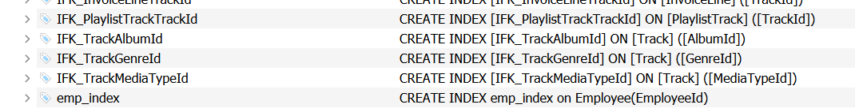

sTHANK YOU